Draft Minutes
Cold Ashby Parish Council
Minutes of the meeting held on Wednesday May 1st 2024 at 7.30 pm at Cold Ashby Pavilion.

Minutes

Present: Councillors Roper (Chair, SR), Bailey (RB), Harpham (NH) Peel (AP), and Richard Williams (RdW). 2 members of the public. Jonathan Ward-Langman (Clerk, JBW-L)
The meeting was recorded by a member of the public.
Declaration of interests: The Chair declared an interest in the item at 24.5.13 due to involvement with Cold Ashby Community Pub Group Limited; he took no part in proceedings for this item.
24.5.1 - Apologies: to receive and consider Councillors Taylor and Rachel Williams. Councillor Kevin Parker (West Northamptonshire Council, Brixworth).
24.5.2 - Minutes: Minutes of the meeting of the Council held on April 3rd, 2024 were approved unanimously, subject to amendment to note that Councillor Rachel Williams was not in attendance (though her apologies had been noted).

24.5.3 - Matters arising: There were none.

24.5.4 - Open forum:
- A member of the public reported that the car referred to at the meeting in April parked on Main Street remained there. JBW-L to follow up. N.B. this can be reported to Northants Police here: Report antisocial behaviour | Northamptonshire Police (northants.police.uk).
- A member of the public inquired regarding the Bus service. See 24.5.9, below.

24.5.5 – Accounts:
- The attached accounts for May were approved, subject to amendment of an error to show the opening balance consistently as £13,090.28. The payments contained in them were authorised.
- Transfer of £1000 to reserves (savings account) was approved.
Proposed NH, seconded RdW, agreed unanimously.
- It was confirmed that expenditure for storage of recordings of Parish council meetings was unnecessary.
JBW-L to investigate Wave bill, payment of grant to (£640) to Friends of St Denys Church (approved in February 2024) and ICO fees. Contact details for bills to be updated.

24.5.6 – Community litter pick: Discussed. To be scheduled for June 30th 2024. JBW-L to contact WNC to arrange bags and collection.

24.5.7 – Planning matters: Planning application mentioned. JBW-L to seek further details.

24.5.8 - Defibrillator. Discussed. JBW-L to liaise with RB re replacement battery.

24.5.9 - 59/60 Bus: Chair updated on progress with Bus company and discussion of route.

24.5.10 – Environment: No business; Chair to arrange trimming of ivy obscuring Main Street name sign.

24.5.11 - D-Day Celebrations. Clerk reported. Village Hall is commemorating D-Day anniversary. No separate action by Council.

24.5.12 - Verbal Reports: from council representatives on other bodies.

- Village Hall; RB reported. Financial position sound, building is well-used.
- Playing Fields; NH Financial position sound, facility is well-used; volunteers being recruited.

24.5.13 - Post: see items of correspondence attached below.

- Letter from Buckby Library Hub: it was felt that this was too far away from the parish to justify financial support.
- D-Day commemorations. See 24.5.11, above.
- Email re Black Horse Public House (The Chair took no part in proceedings for this item due to a conflict of interest, see above): received on April 27th, 2024, after production of agenda. It was agreed to consider this matter as it related to decisions taken by the Council previously.
It was agreed that a letter of support for the principle of re-opening the Black Horse as a Public House should be sent by the Council ‘to whom it may concern’. JBW-L to draft, NH to sign. This was proposed by AP, seconded RB, all in favour, RdW abstaining.

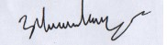

Jonathan Ward-Langman May 10th 2024

 |  | May-24
Date | Account | Category | Desc | Credit/Debit | £ | VAT | Total
01/03/2024 | Main | Opening Balance |  |  | £13,090.28 | £0.00 | £13,090.28
01/03/2024 | Savings | Opening Balance |  |  | £8,726.34 | £0.00 | £8,726.34
28/03/2024 | Savings | Interest |  | Credit | £9.71 | £0.00 | £9.71
29/03/2024 | Main | Consumables/IT | Ionos Cloud | Debit | -£3.00 | -£0.60 | -£3.60
03/04/2024 | Main | Venue hire | Cold Ashby Memorial Hall | Debit | -£157.50 | £0.00 | -£157.50
04/04/2024 | Main | NCALC | NCALC - membership etc. | Debit | -£254.87 | -£2.40 | -£257.27
04/04/2024 | Main | Streetlights | NPower | Debit | -£251.45 | -  £12.57 | -£264.02
08/04/2024 | Main | Grasscutting | Thompson Groundcare | Debit | -£232.96 | -  £46.59 | -£279.55
15/04/2024 | Main | Streetlights | Eon | Debit | -£192.00 | -  £38.40 | -£230.40
 | Main | Total |  |  |  |  | -£1,192.34
 | Savings | Total |  |  |  |  | £9.71
 |  | Above payments authorised:
April 25th 2024 | Clerk | Jonathan Ward-Langman | 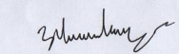
 | Councillor |  |  | Main Account |  |  | £11,897.94
 | Councillor |  |  | Savings account |  |  | £8,736.05
 |  |  |  | Month Balance |  |  | £19,451.36
 | Date:

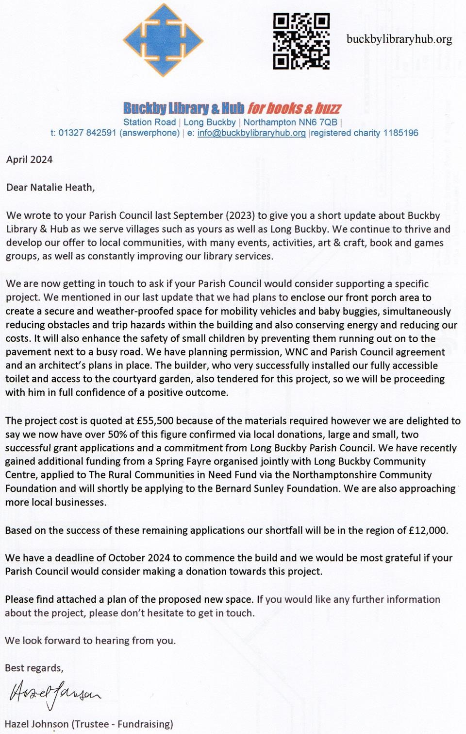

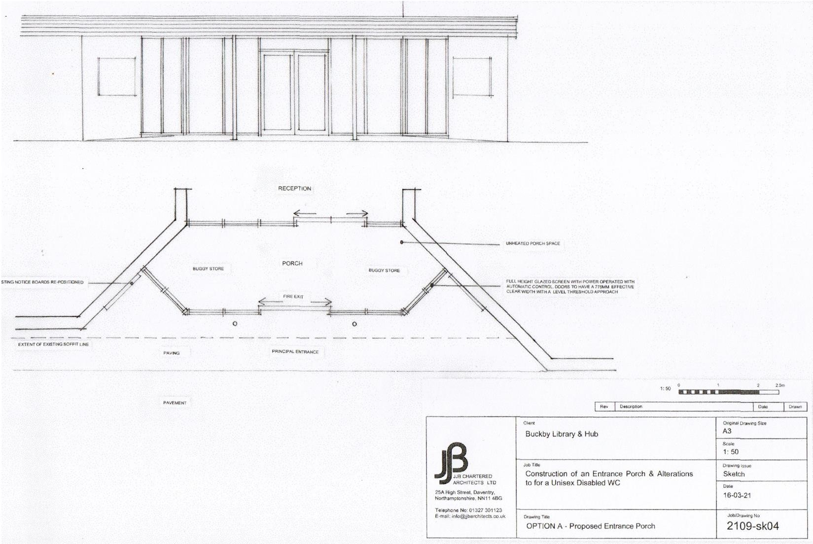
Email from Royal British Legion Industries
As we approach the anniversary of perhaps the most pivotal moment in the Second World War, RBLI is proud to unveil our new D-Day 80th Anniversary decorative collection to help your parish council join the many others across the UK in commemorating this momentous milestone. The decorations, made or fulfilled by veterans and those with disabilities in the UK, stand testament to the unwavering courage and sacrifice displayed by the brave soldiers who stormed the beaches of Normandy on 6th June 1944.
At RBLI, we believe that it is of upmost importance that the sacrifices made by our veterans are recognised and remembered by our nation, with dedications being prominently displayed in the local community. Our range of lamp post signs, flags, and Tommy statues is designed just for this.
Will you join us in this nationwide commemoration?
Please note that RBLI is an entirely separate charity from The Royal British Legion in governance and finance, sharing similarities for historic reasons but receiving no income from the Poppy Appeal.

Royal British Legion Industries Registered Charity Number:
England & Wales 0210063 | Scotland SC048795 | VAT Number GB916326234
Every item purchased directly provides vital employment and income to aid vulnerable veterans that have fallen on hard times, so when you choose our products, you are not only paying homage to our heroes but also supporting the livelihoods of those who have served our nation.

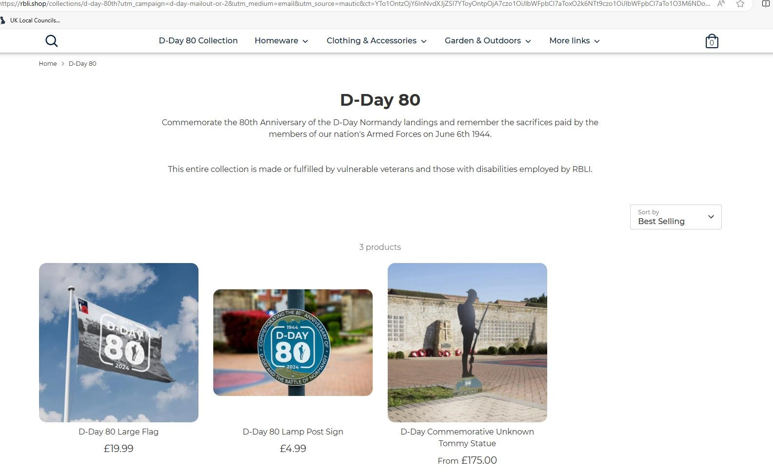
27/04/24

Dear Jonathan,

Our village pub, The Black Horse, has been closed now for four years. An ACV ( asset of community value) was placed on the pub in February 2021. A group was then formed with the sole aim of reopening the Black Horse and has widespread support from within the village and surrounding areas.

As you may know, Cold Ashby Community Pub Group (CACPG) are currently in negotiations with the Owner of the Black Horse Public house, with a view to purchase the freehold.

We are at the early stages of discussions; however, progress has already been made in the application for Government grant aid.

Part of the success of obtaining grant aid as displayed in previous examples, has been the support for the projects from the Local Parish Councils . We would therefore be most grateful for a written letter from Cold Ashby Parish Council in their support of the aims of CACPG and the reopening of the Black Horse public house for the benefit and enjoyment of our community.

We look forward to hearing from you.

Kind Regards,

Katy Stuart.
Secretary for Cold Ashby Community Pub Group Limited. (CACPG)

